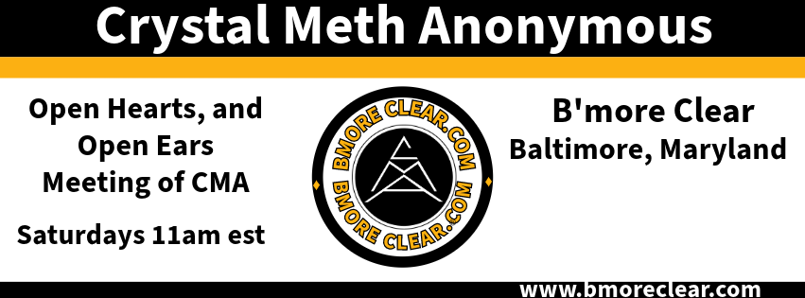
Meeting Script
Hello, and welcome to the Open Hearts and Open Ears meeting of Crystal Meth Anonymous. My name is ________________, and I’m a crystal meth addict. Can we start with a moment of silence and then join me in the Serenity Prayer:

God, grant me the serenity to accept the things I cannot change; the courage to change the things I can; and the wisdom to know the difference.
Welcome, if you’re seeking recovery, you’re in the right place. Thank you for being here and celebrating your recovery with us. CMA is an inclusive fellowship of people for whom all drugs, especially crystal meth, have become a problem. The only requirement for membership is a desire to stop using. Anonymity reminds us that the strength of our unity comes from our diversity. Anyone may join us and harassment of any kind will not be tolerated. CMA is a safe space! In short, no matter who you are, where you come from, what you look like or what you believe in – you are loved, regardless and always welcome here.

Is there anyone new to CMA, or new to this meeting who would like to introduce themselves? If you are new, we encourage you to place your phone number in the chat. We will be honored to share our experience, strength, and hope with you. The Baltimore fellowship also operates a private Facebook group called “B’more Clear.” If you would like to be added, please send me a chat and I will be sure to add you to the group.
This is an open meeting of CMA. We read the daily meditation from “Just For Today” and then the meeting will be open for sharing. We take a break for announcements midway through and to honor the 7th Tradition. Let’s begin!
I have asked _____________________ to read “What is the Crystal Meth Anonymous program?”
I have asked _____________________ to read “Are You a Tweaker?”
I have asked _____________________ to read “The Twelve Steps of CMA.”
I have asked _____________________ to read The Tradition of the month.
Thanks to everyone for reading. I will now share the Just For Today.
The meeting is now open for general participation. To prevent confusion, please raise your virtual hand, if you would like to share. When sharing, please be careful describing drug effects, as some of us may be triggered and the desire to use heightened. Remember the recovery of others and avoid glorying drugs or drug-driven sex. We realize it’s a part of many stories and needs discussion; however, the secretary may interrupt and refocus. The meeting is now open.
(At the 30-minute mark)
We are self-supporting by our own contributions. We have no dues or fees, but we do have expenses. The 7th Tradition will now be observed, and the Venmo information placed into the chat (See note below). At this time, are there any announcements for the good of the fellowship?
(GSR Announcements)
At CMA, we understand the early days of recovery are difficult and need support to get through. We invite anyone counting days up to 90 days to introduce themselves and share their day count now.
Would those with 90 days to 6 months please raise their hand?
6 months to 9 months?
9 to 12 months?
Anyone with a year or more of clean time?
May we see a show of hands for those willing to sponsor or speak to newcomers after the meeting?

If you are looking for a sponsor, please see one of these members after the meeting. They will be honored to share their experience, strength and hope with you. The meeting is again open for general participation. Remember that anonymity is the spiritual foundation of all our traditions. What is said here, who is seen here, when you leave here, let it stay here: Here, here!

(Five minutes prior to the end of the meeting)

Thanks to everyone who shared. Our meeting is about to close, but we always save time for burning desires. A burning desire is defined as “I will use or hurt myself if I don’t get to share this now.” Before we end, are there any burning desires?

(If none, and there is time)

If there are no burning desires, we have a few minutes left for anyone who didn’t get a chance to share.

(At end of meeting, or at the hour)

I would like to thank everyone for making this a great meeting today! We have one final reading and then will close with the serenity prayer. Can someone please read “Today I Can.”

(After the reader finishes)
Can we now have a moment of silence and then follow me in the Serenity Prayer:

God, grant me the serenity to accept the things I cannot change; the courage to change the things I can; and the wisdom to know the difference. Keep coming back, it works if you work it.

*NOTE Venmo Info: Welcome! Enter contact info in the chat to stay in touch. Contributions to the 7th tradition can be made via Venmo or PayPal to: JamessnDC@Yahoo.com. You can also access additional CMA meetings in MD and DC here: https://dccma.com/meetings-beta/

